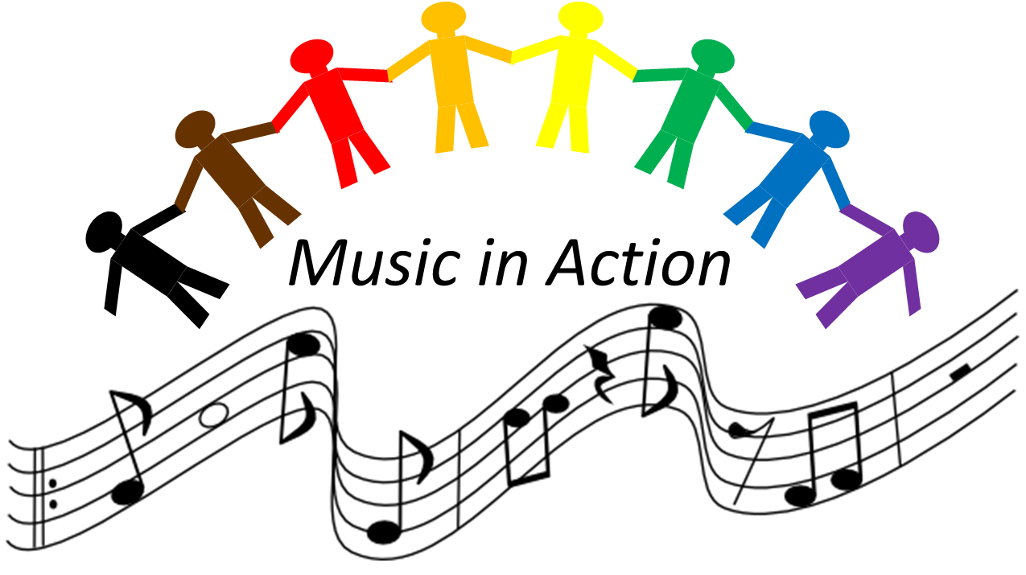

The Richard Wagner Society of the Upper Midwest
Music in Action Grant Application

Applicant Information

Name
Address |  | City, State, Zip
Phone |  |  | Email
Are you a US Citizen, have permanent resident status, or are otherwise legally able to work in the US? |  |  |  |  |  | Yes | No
Are you applying as an individual artist? |  |  |  |  |  | Yes | No
Briefly describe how your work and income have been negatively impacted by COVID-19:

Proposal Information

Please give a 2-3 sentence summary of request:

Funding Amount Requested: $_________

Project completion date: ___________

Work Samples (3-5)

Please list your submitted work samples here:
1.
2.
3.
4.
5.

Artist Statement

Project Narrative

Community Connection/Intended Audience

Outcomes

Technological Capacity

Budget (may be submitted as separate attachment)

